How to Create a Catalogue Requisition
- New look screens in UniCore

1.1 SCM_RSSP_Create a Catalogue Requisition

Create a Catalogue Requisition in Redwood
Amazon orders – For all orders placed with Amazon, please ensure that the (UDFC) User Defined Fiscal classification field has standard VAT applied please.

All Amazon orders are subject to VAT.

Catalogue Requisition is where the requisition is for an item which is covered by pre-specified agreements such as price list.

Log on to UniCore using the company single sign on button.

Find ‘Procurement’ in the horizontal menu, and then click on ‘Purchase Requisitions (New)’

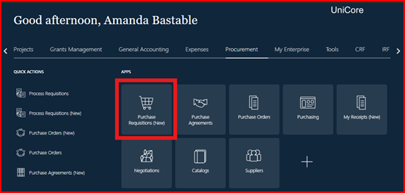
This will bring you through to the Self-Service Procurement page, here you will have 2 options, option 1 is where you can type in keywords in the search bar to build a search for the items you would like to order.

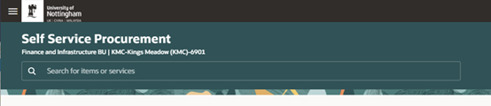

Once you have entered your keywords and searched for your item, this will bring up your search results.

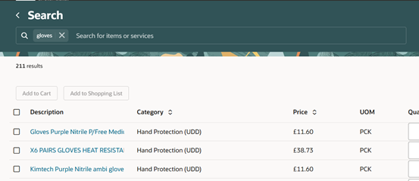

You can then select your items from this list, either by clicking the item description, and adding it to your cart from the ‘Product Details’ page. Or by selecting the box to the left of the item description and selecting ‘Add to cart.’

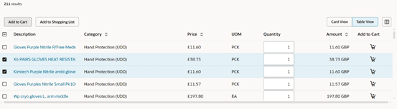
To add another product, enter a short description or agreement number, if known, into the Search field, as shown in previous steps.
Note: If there are regular items that you order, there is the option to use the favourite products button or even Save a basket as a shopping list

Option 2, select ‘Punchout’ at the bottom of the screen to visit a specific supplier website. There is a search function, and you can change the way the suppliers are displayed in this window. 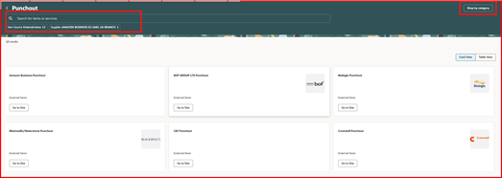

Once on the supplier's website, search for your items, and add them to your basket. Below is an example of an Amazon order.
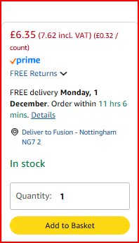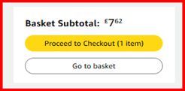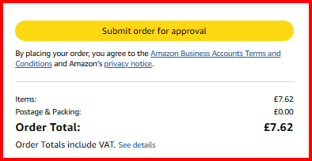

Below is an example of an RS Components order. Select ‘Return requisition.’

Please take note of the delivery date of your order, once this date has passed you will receive an invoice hold notification for goods receiving the order, as the Unicore system is reacting to the date input by the requester at the time of ordering. if the supplier informs you of a delay to your delivery you will need to amend the delivery date of your order as and when needed. The notifications will stop until the new date passes.

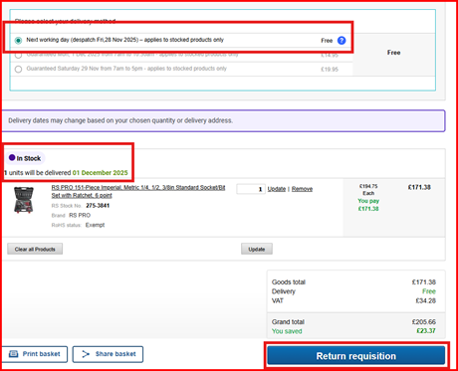

Note: You can delete items or decrease/increase quantities or change any other such detail at this stage.
Once you have selected ‘return requisition you will be presented with the page for your cart. Here you will see all the required items in your cart and can then select the Edit line details (pencil icon) and billing and delivery details (Lorry icon). You can also edit multiple lines by selecting the box at the top of the screen and selectin ‘Edit Multiple.’

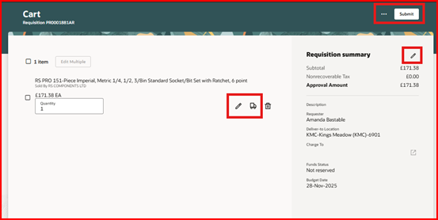

Select the pencil icon to edit the line details. In this screen, you can amend the quantity, add comments for the supplier if required, and add attachments. There is also a drag and drop function for attachments.

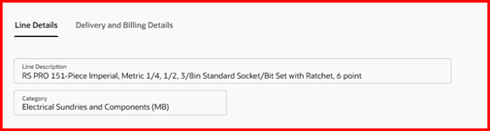

Further down this screen is the ‘Additional Information’ section. Here you can add the delivery room number, select whether Health & Safety approval applies to your order, and select from the LOV for the Procurement process. If you have selected the quotes option, you will be able to add your attachments to this screen.

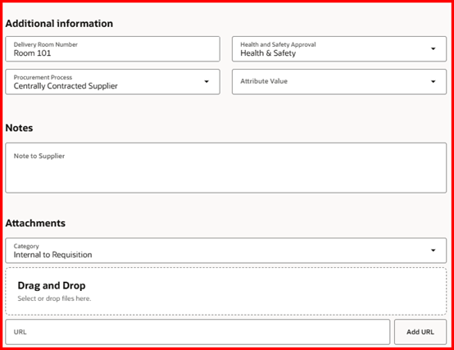

Next, select ‘Delivery and billing’ details. In this screen, you can amend the requested delivery date, the location of the delivery, and the (UDFC) User Defined Fiscal Classification. Please ensure the correct VAT treatment is applied at this stage as an invoice hold will be created if the invoice from the supplier does not match these details. A change order may be required to rectify this issue.

Please note: Amazon orders are subject to 20% VAT.

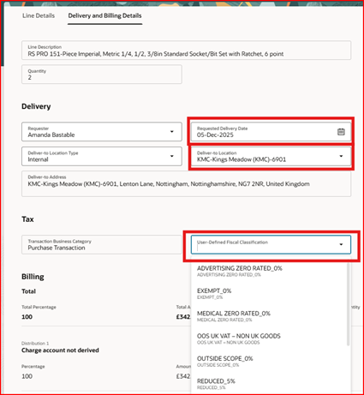

Next, select the pencil icon in the requisition summary section.

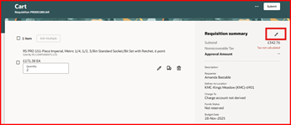

In this screen, you will be required to add a description and a justification for the order.
Also, you can amend the requester, Requested delivery date and delivery to location.
Here you can add the project number if required and the Charge account; this is the (COA) chart of account string. You can also add the Budget date.

If your order is to be charged to the school/faculty cost centre, you will select the diagonal arrow in the charge account field and add your chart of account string. If you have added this in your preferences, this will be displayed here for selection.

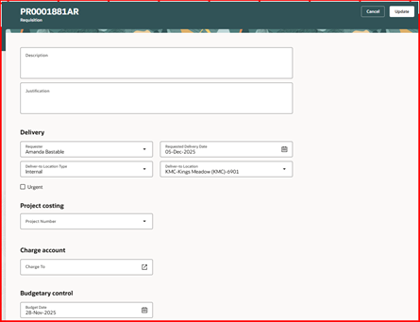

Search through each segment of the string for your company, cost centre, purpose code, and account code. The last 3 segments are usually 99999999, 99, & 99999. In some cases, the analysis segment will be different. The project codes in some instances.

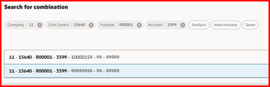

If a project code is being added as well as the (COA) charge account. You will need to return to the delivery and billing screen and in the charge account section select the 3 dots and choose ‘Edit’.
If you require to split the cost between different cost centres or projects, you can do this by selecting ‘Split’ you will need to add the percentage of the split or the monetary value.

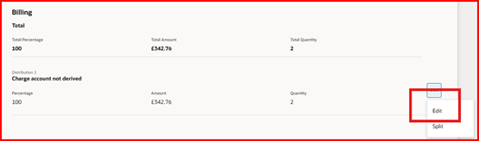

Here you will be able to add both project code and charge account. Please add the charge account first, then the project code. If you select the project first, it greys out the charge account section and it cannot be amended. If the project is present on this page, please remove it, add the charge account, and then add the project code again and select ‘update’ at the bottom of the screen to save these details.

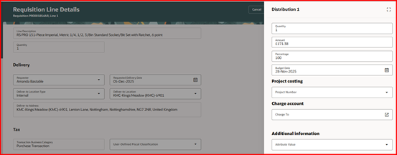

The Requisitioner can also update Delivery details for each of the requisition lines. The information can be updated in the delivery and billing section.
- Requester: This is the person on whose behalf the requisition is required to be created. The requester's name is defaulted from the Requisition Preference.
- Requested Delivery Date: This is the date when the requisitioner wants the supplier to deliver the goods. By default, it will be set to 7 days from the present date. The requisitioner can change the date as required. In some cases, suppliers can provide the goods the next day. If this applies to your order, please input this date.
- Deliver to Location: this is defaulted from the Requisition Preference. The requisitioner can update ‘Deliver to location’ if required ‘

Note: It is important to note that delivery details are unique for each requisition line. The requisitioner is to click on the requisition line for which delivery details are required to be updated based on the supplier’s availability of goods.

Specify Charge Account Details in the ‘Delivery & Billing’ Section.

- Project Number: enter the project number incurring the charge from the requisition, purchase order, or invoice.
- Task Number: the lowest level task incurring the charge from the requisition, purchase order, or invoice.
- Expenditure Type: is an expenditure type classified with an expenditure type class of Supplier Invoices.
- Expenditure Organization: the organization that is ordering or has ordered the goods or services, which may be different from the project owning organization.
- Expenditure Item Date: the date that you expect to incur the expense for the goods or services that you are requesting a requisition or purchase order, or the date that you incur the charge for an invoice. This date is used during online validation against project transaction controls and becomes the expenditure item date on the expenditure item in Oracle Projects.

Note:
- Contract Number and Funding source will be enabled and mandatory if the project number entered in project number segment is of capital type
- VAT treatment dropdown should have the same value as User-Defined Classification dropdown or your requisition will get auto rejected.
- When making any purchases on a project, the Expenditure Type and the Account in the Charge Account must match. Inconsistencies are causing challenges in keeping the project ledger and the general ledger reconciled.
- We are aware that it is possible to change the Expenditure Type manually. The account in the Charge Account string is derived from the product code of the purchase item and is fixed. It is therefore necessary to change the Expenditure Type to match the Account in the Charge Account string before submitting the purchase order

Approvals: These are triggered based on cost centre and approval limit.

The table below shows the stages of approval flow.
Approval Stage | Approvers | Condition
Stage-1 | Project Manager | Project Type Requisition, amount greater than x
Stage-2 | Cost Centre Based Approval Groups | Mandatory Stage Applies to all Requisitions
Stage-3 | Health & Safety Team | When Requester Chooses Health and Safety on Requisition Header DFF
Stage-4 | Tax Team | When Requisition Amount is Greater Than 5K and Tax Classification Code is Medical 0%

Once all details have been reviewed, and any relevant documentation attached using the ‘Notes and Attachments’ section, click ‘Submit’ to submit the requisition for approval.

At this point, the requisition shows as approved and provides a purchase order number but is in the workflow for Cost centre and Project approval. It means it is approved to go to the supplier or the Buyers Dashboard for processing in the case of non-catalogue orders.

